
Assignment Part 2: Interactive Dashboard for Healthcare Quality Monitoring

CPSC600, Advanced Data Visualization, Section 01:- Summer 2025
Hamidreza Kermajani
By
Ohm Patel,
Vassu Patel,
Sharma Rahul,
Uchendu, Kelechi.

August 24, 2025

Hospital Performance Dashboard
The purpose of this dashboard is to help healthcare regulators and decision makers monitor hospital performance and identify areas where hospitals may need improvement. To achieve this, I designed an interactive Tableau dashboard that combines several types of charts, filters, and parameters. Each chart was selected to answer a different type of question: Which states are performing well? Where are the hospitals located? How does ownership or emergency services affect outcomes? What patterns can we see when comparing different indicators? Below, I describe each visualization, how it was built, and what insights it provides.

Average Hospital Performance by State
The bar chart gives a simple comparison of average performance scores across states. It was built by placing “State” on the rows and “Indicator Value” (average) on the columns. It shows which states have higher or lower average scores and includes labels for the number of hospitals in each state. This is important because it gives a quick nationwide ranking and provides context by showing how many hospitals contribute to the averages.
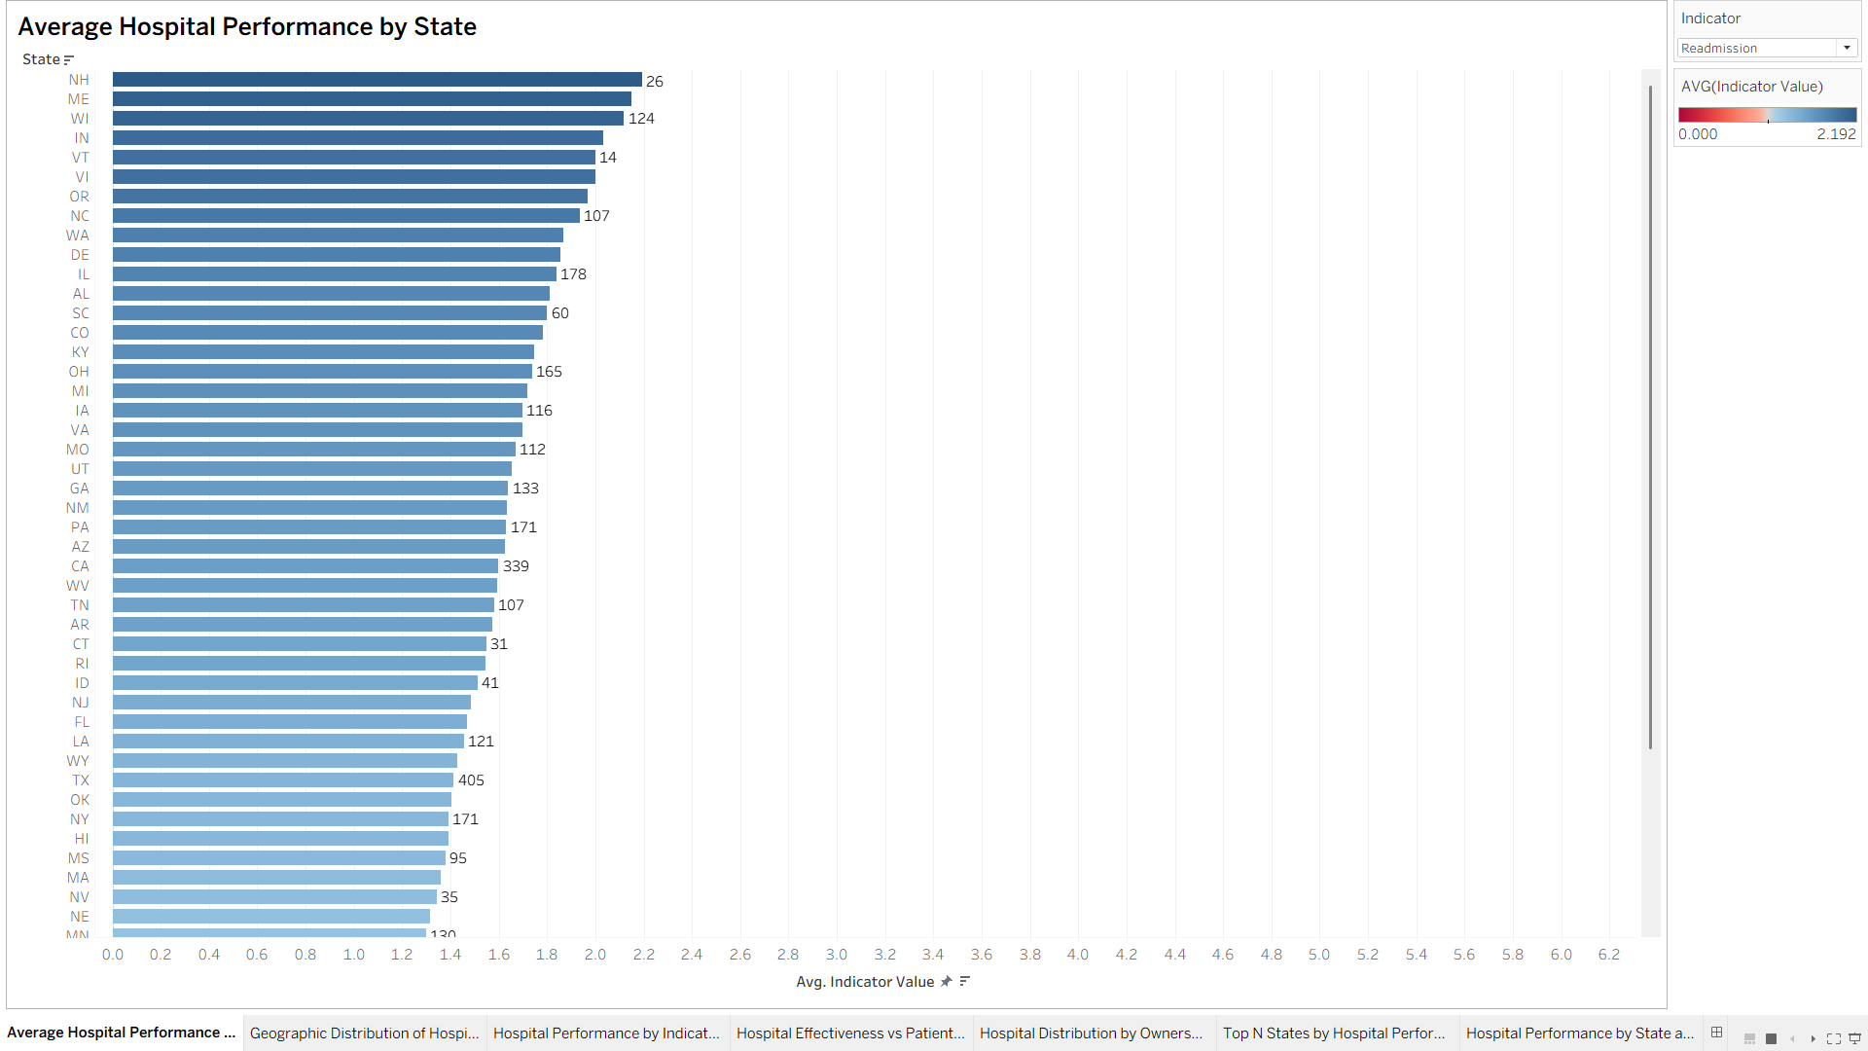

Geographic Distribution of Hospital Performance
The map adds a spatial view. Using “State” as geography and coloring by the average Indicator Value, the chart reveals regional patterns. Regulators can see clusters of low or high-performing areas. For example, certain regions may consistently lag behind in timeliness of care or readmission rates.
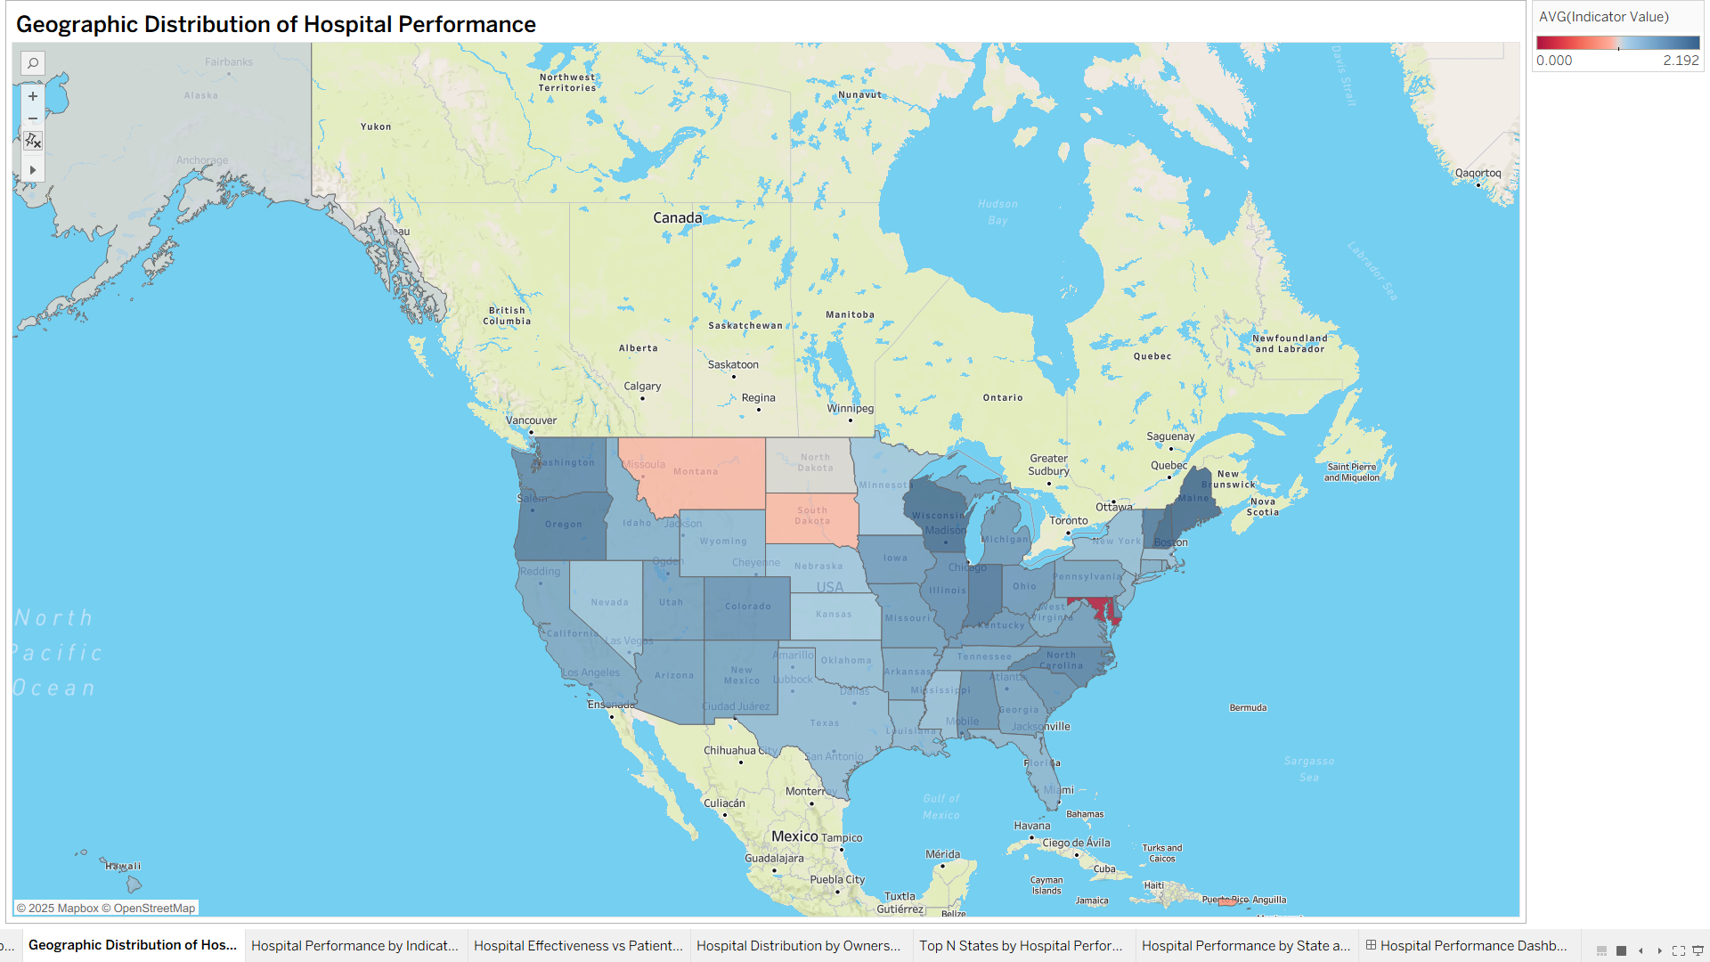

Hospital Performance by Indicator Bucket and Emergency Services
The stacked bar chart explores the role of emergency services. I created a calculated field to group performance into Low, Medium, and High buckets. Then, I split the bars by Emergency Services (Yes/No). This chart shows whether hospitals with or without emergency services tend to perform better. It highlights how access to emergency care can affect outcomes.
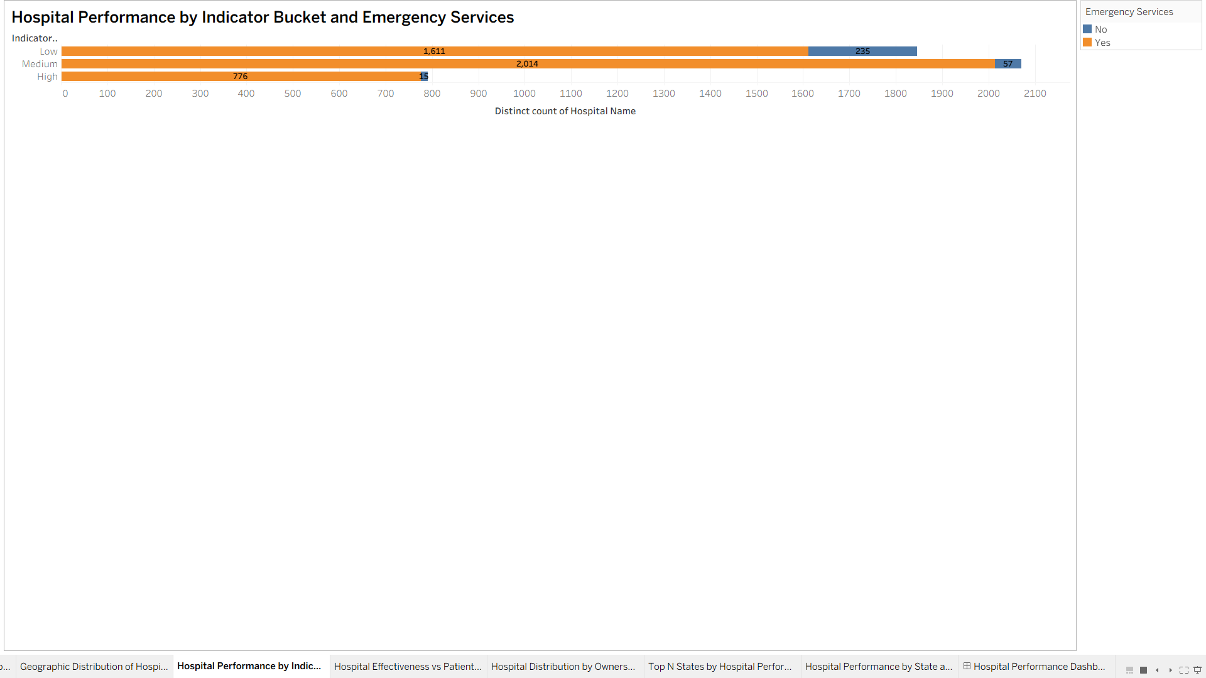

Hospital Effectiveness vs Patient Experience
The scatter plot shows the relationship between two indicators. Each dot represents one hospital, with colors for hospital type. Effectiveness is on the x-axis, and Patient Experience is on the y-axis. This helps identify patterns or outliers, and whether strong performance in one dimension aligns with strong performance in another.
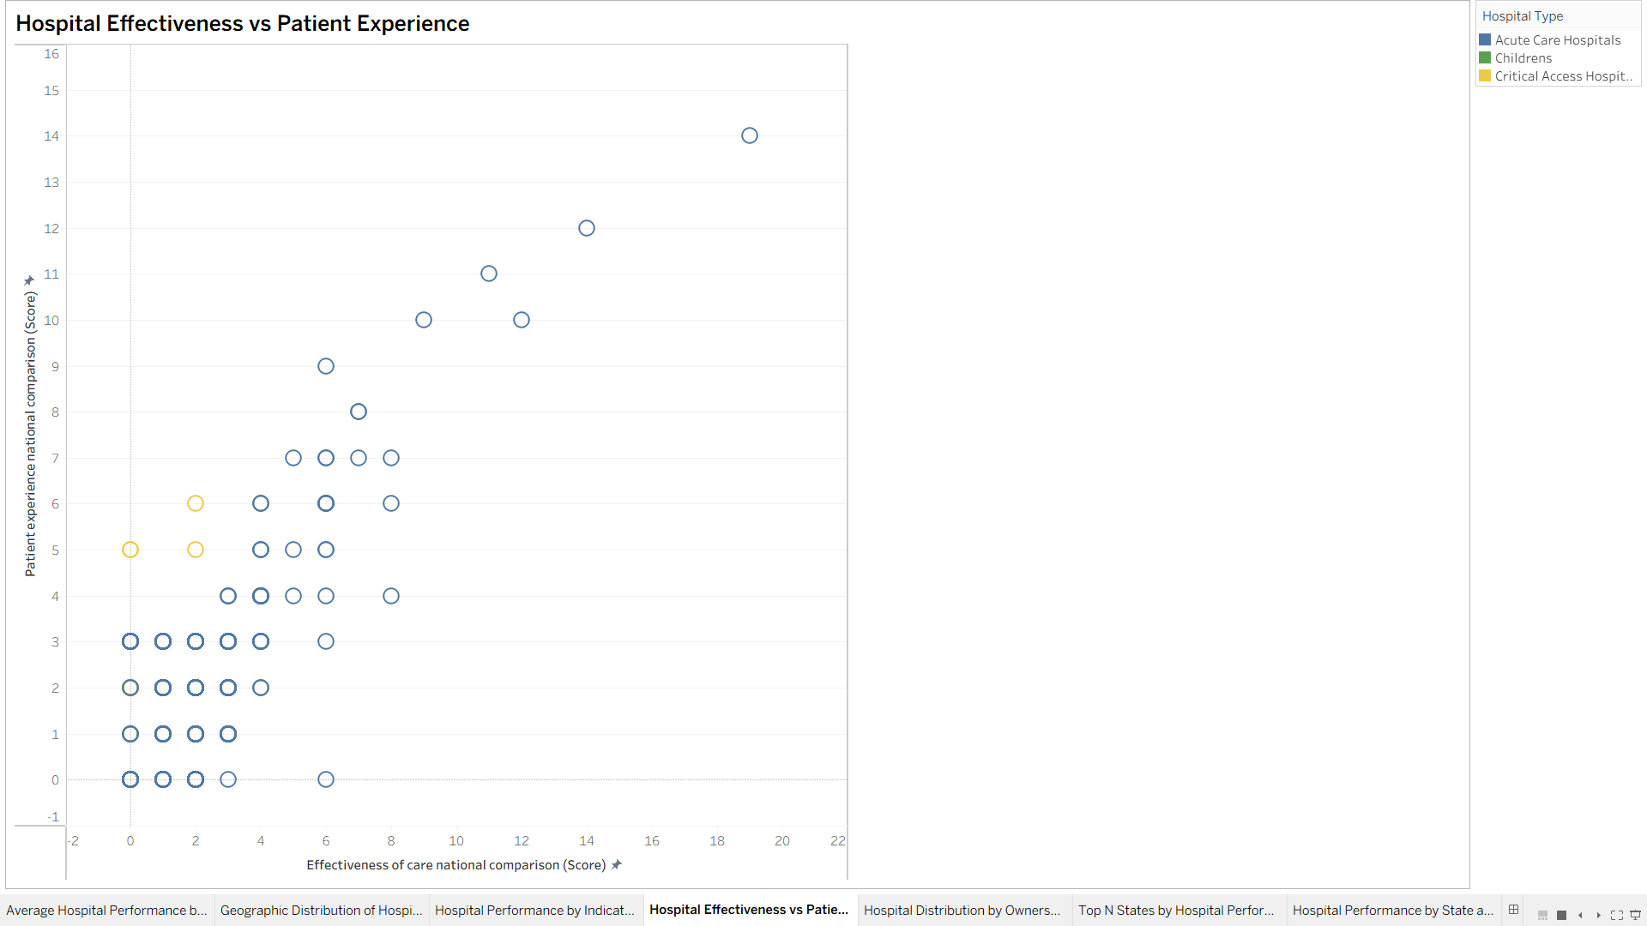

Hospital Distribution by Ownership Type
The tree map highlights how hospitals are distributed across ownership categories. Each box represents an ownership type, sized by the number of hospitals. This gives a quick overview of how much of the healthcare system is managed by non-profit, government, or proprietary hospitals.
➤ 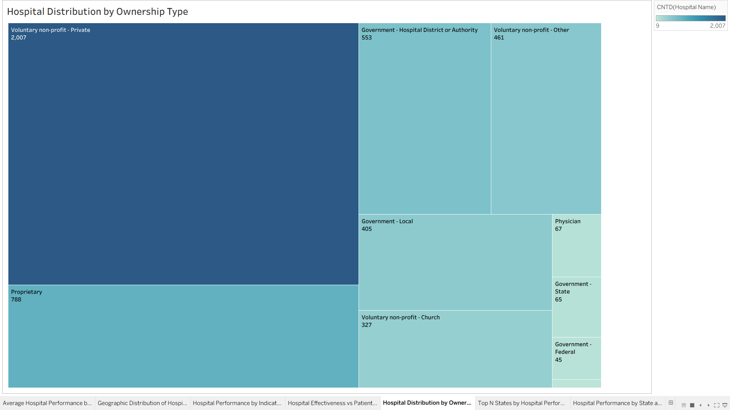

Top N States by Hospital Performance
This chart introduces interactivity. A parameter allows users to pick “N” (for example, top 5, top 10, or top 20 states). Tableau filters states by rank and shows only the top N performers. This feature helps users quickly focus on the best states.
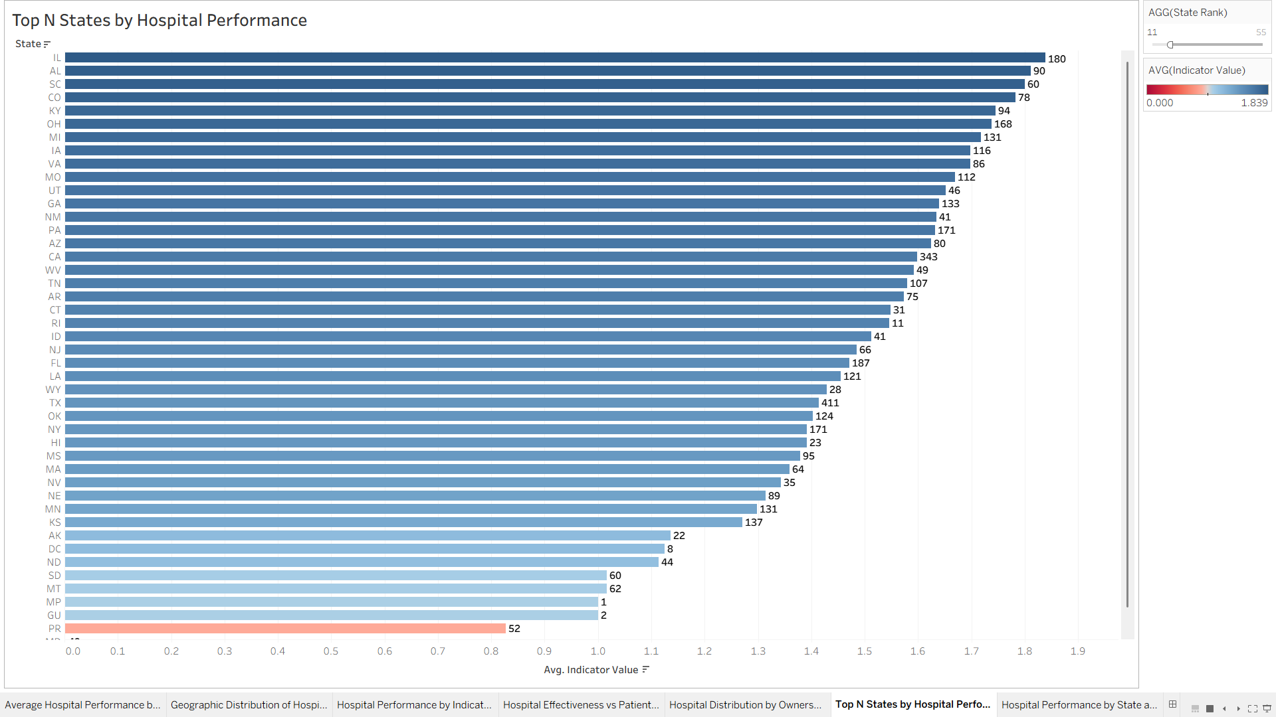

Hospital Performance by State and Hospital Type
The heat map shows differences in performance across both State and Hospital Type. Each cell is colored by average score, allowing regulators to compare performance between Acute Car, Critical Access, and Children’s hospitals.
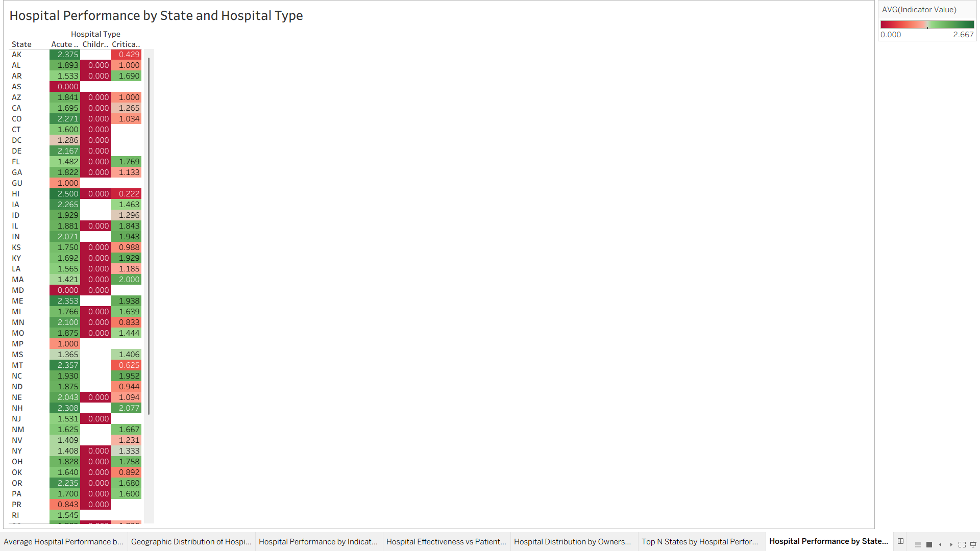

Final Dashboard
Finally, all charts were brought together into one interactive dashboard. The top section shows overview charts (bar + map), the middle highlights emergency services, and the bottom provides advanced insights (scatter, tree map, heat map, and Top N). Parameters (Indicator, Top N) and filters (State, Ownership, Type) give users flexibility. Actions were added so clicking a state filters other charts. Colors are consistent (green = better, red = poorer, gray = missing).
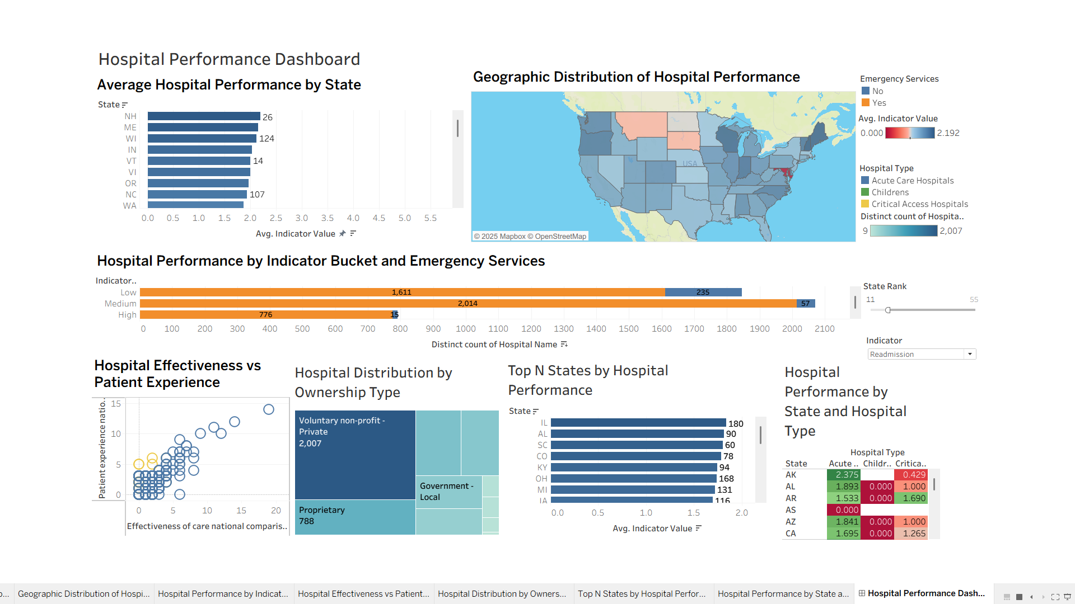

Conclusion
This dashboard combines overview, drill-down, and exploratory charts. It provides regulators with multiple perspectives on hospital quality, ownership, and emergency services. Compared to a simple dashboard, this design emphasizes clarity, interactivity, and usability, making it easier to identify low-performing institutions and prioritize regulatory attention.

References
Centers for Medicare & Medicaid Services (CMS). (2023). Hospital general information dataset. Kaggle. Retrieved from https://www.kaggle.com/datasets/cms/hospital-general-information
Tableau Software. (2024). Build views and dashboards in Tableau Desktop. Tableau Help.https://help.tableau.com/current/pro/desktop/enus/gettingstarted_overview.html.

